📘 Structural Pseudo-Class – CSS-Only Notes (with HTML Connection)

✅ :first-child
📌 Meaning:
Jo element apne parent ka sabse pehla child ho.
🔗 Connected HTML:
<div>
<p>1st paragraph</p> ← 🎯 Targeted
<p>2nd paragraph</p>
</div>
🎨 CSS:
p:first-child {
color: red;
}
Code
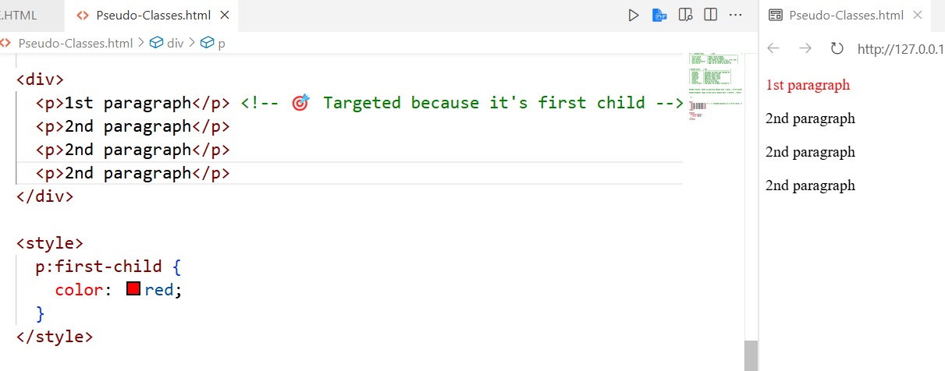

✅ :last-child
📌 Meaning:
Jo element parent ka aakhri child ho.
🔗 Connected HTML:
<ul>
<li>Item 1</li>
<li>Item 2</li>
<li>Item 3</li> ← 🎯 Targeted
</ul>
🎨 CSS:
li:last-child {
color: blue;
}

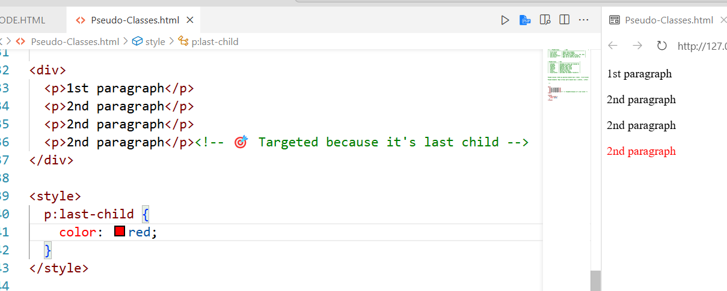

✅ :nth-child(n)
📌 Meaning:
Parent ka nth number ka child target karta hai (1-based index).
🔗 Connected HTML:
<ul>
<li>Item 1</li>
<li>Item 2</li> ← 🎯 2nd child
<li>Item 3</li>
</ul>
🎨 CSS:
li:nth-child(2) {
background: yellow;
}
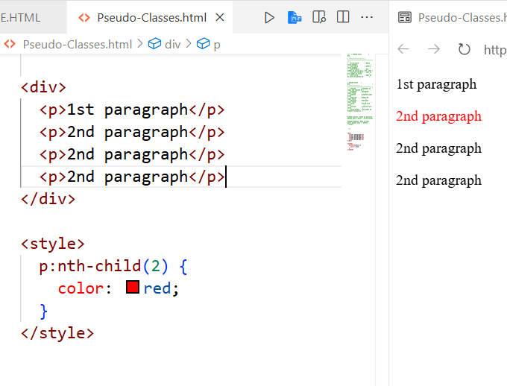
EXAMPLE 2 :
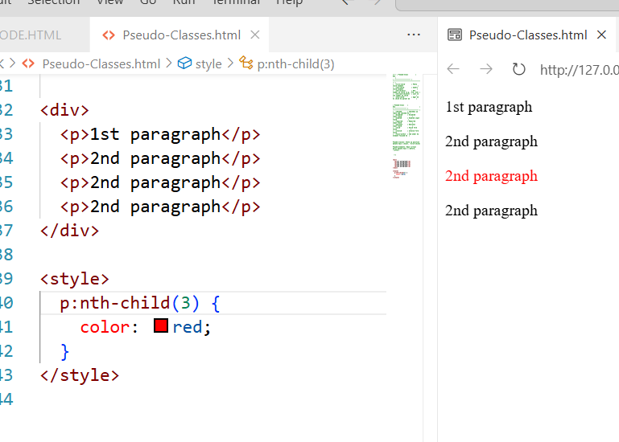

✅ :nth-last-child(n)
📌 Meaning:
Counting last se hoti hai, nth child ko target karta hai.
🔗 Connected HTML:
<ul>
<li>First</li>
<li>Middle</li>
<li>Last</li> ← last-child (1st from end)
</ul>
🎨 CSS:
li:nth-last-child(1) {
font-style: italic;
}

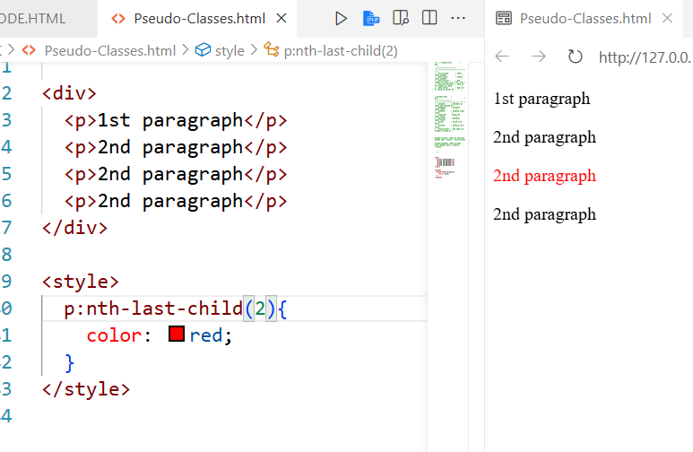

✅ :only-child
📌 Meaning:
Agar parent ke paas sirf ek hi child ho, toh use target karega.
🔗 Connected HTML:
<div>
<p>Single child</p> ← 🎯 Targeted
</div>

<div>
<p>1</p>
<p>2</p> ← ❌ Not targeted
</div>
🎨 CSS:
p:only-child {
border: 2px solid green;
}

